2015 Notes on Performing Observations for Harbor Porpoise Study at Burrows Pass

What you will need
Observation materials:
Printed observation form
Pen/pencil
Binoculars
Timing device

Clothing and accessories
Dress appropriately for the weather, keeping in mind that it’s often windy up on the bluff and you will not be moving for a couple of hours. Layers are great for adjusting to any weather changes. We recommend:

Windbreaker jacket
Windbreaker pants
Insulating top
Insulating pants
Hat (with brim for sunny days)
Sunglasses (polarized lenses) – these do make a difference
Sturdy skid-resistant shoes
Sunscreen
Snacks
Beverages

Getting started with your observations:
Familiarize yourself with the grid map, and make a mental note of the land marks that will help you orient yourself later. Remember that the grids are 45 degree angles.

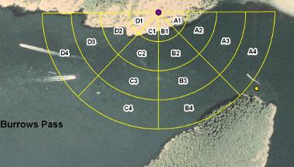

The line separating grids A and B intersects the first large cove on the edge of Burrows island (the tip of the island is in grid A) see arrow:

Grid A Grid B
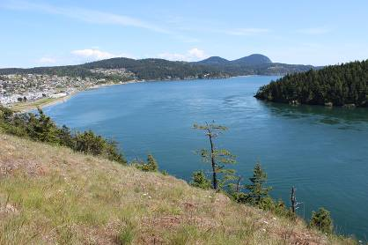

The line separating grids B and C intersects with the first ‘dip’ in the tree line (see arrow):

Grid B Grid C
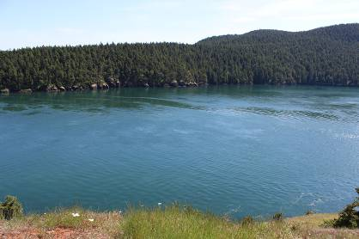

The line separating grids C and D intersects the small beach/where there is a line of trees missing (see arrow), the tip of this end of Burrows island is in grid D:

Grid C Grid D
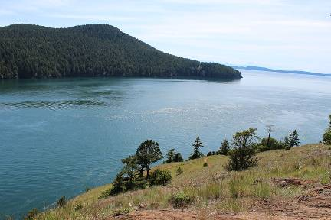

Next familiarize yourself with the cells within each grid (1 through 4). Because of your perspective from high on the bluff, the rings that are farther away will appear narrower, even though they are the same size. Cell 1 is close to Fidalgo island, cell 2 takes up more of the pass than any other, cell 3 appears to be smaller than cell 2 and cell 4 is farthest out and close to the island. The image below shows cells for A and B
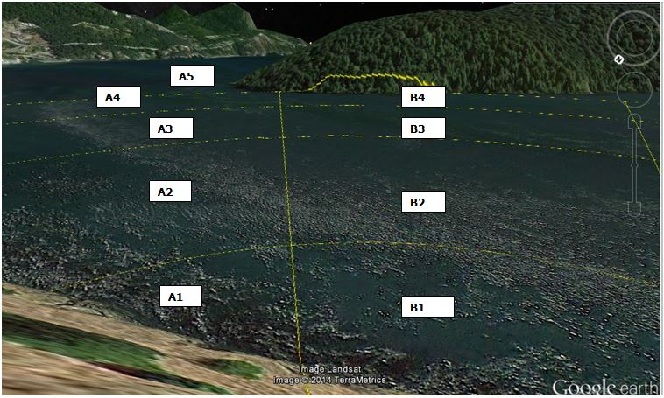

And C and D are shown below

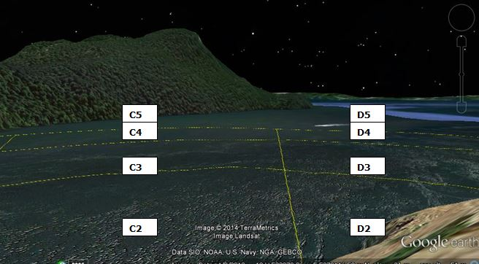

**Please note – the grid does NOT encompass the whole pass – Grid D ends about ¾ of the way through the pass. We are intending to only track the porpoises in cells A through D, rings 1 through 4. However, since many porpoises are seen in the area around the buoy, we have designated A5 to be everything outside.
A great way to remind yourself of where cells 4 are (the edge of the study area) is to put your arm out straight in front of you along the line between grid B and C, pointing to the shore (this is the middle of the grid). Move your arm left and right, and the arc that you create will roughly give you the edge of the study grid (remember it is an arc!) Thank you to volunteer Bob Weathers for that helpful hint! And thank you to Bruce McDanold who first draped the grid on the landscape. The grid shown in the figures has been adjusted to be what an observer standing at the observer location – 47 meters above the water - would see.

I have transparencies that I can provide you that you can line up with the island and have the approximate grid lines printed on them. They may help you get used to where the lines should be. If you would like a copy of these, or if you have any questions please email porpoise@pacificbio.org.

Weather notes: On the observation form, make a note of the weather conditions (high overcast, low overcast, partly cloudy, or clear), precipitation, temperature, wind direction and strength, and Beaufort scale. Note the time you are beginning.

Identifying porpoises: Porpoises swimming appear as a dark ellipse--topped by a dorsal fin—rolling through the water. Often you may see a glint or sparkle as the sun reflects off their body when they surface. Sometimes you may be alerted to their presence by several gulls circling overhead the area where the porpoises are foraging. Watch for several rolls to confirm your sighting, and double-check with your binoculars when possible.
Other animals that could be confused with porpoises on the water include seals, otters, and birds. Seals usually pop their heads above the water, appearing as a shiny “bowling ball” or, farther off and if horizontal, an exclamation point (their body forming a line and their head a dot). Otters swim more continually at the surface than porpoises. Birds can pop above the water and then quickly dive back down, appearing to an unfocused eye deceitfully similar to a porpoise taking a breath. Hence, confirming additional rolls or double-checking through binoculars is important if you are not certain that you have seen a porpoise.

Monitoring the grid: Be sure to check all areas of the grid—from shore to shore, and from one side of the pass to the other the farthest edge of the water. Find a strategy that works for you—gaze at all areas of the water, circle your eyes from one grid area to another, or sweep your eyes back and forth across the water. Also use your ears—at times you can hear the porpoises taking breaths as they surface.

Recording porpoise activity: On the sheet, you will record your observations in ten-minute intervals. If you see porpoise(s), note the grid in the grid column, the number in the number column and the behavior in the behavior column (behaviors are described below). If they cross from one grid block to another enter the block where they spent the most time. If you see more than one group of porpoises at a time, note the next group in the next trio of columns. Watch carefully to determine the number of porpoises you are seeing. Only record the number you are certain you see.

Often you will see porpoises outside of the grid. If you see them by the buoy please record as grid A-5. If they are between the edge of C-4 (when it curves away from the island) and Burrows island record as grid C-5. If they are towards the mouth of the pass record as D-5 (if they are actually outside of the pass, please mark as D-5, but make a note in the notes section that they were just outside of the pass.) Note that there is no B-5, this is because the edge of B-4 goes right along the shoreline of Burrows island.

Here are some examples of what you might see:

This picture was taking a little closer to the water, so the porpoise you will see will look smaller and farther away, but this is a typical surfacing, and you will also note here the sun spot/flash you sometimes see when they surface:
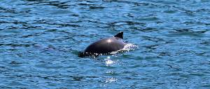

Here a porpoise has just splashed back into the water:
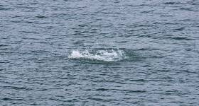

Here is a porpoise swimming just under the surface – likely chasing surface fish:
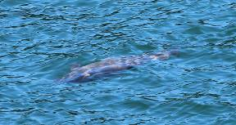

If the porpoise is inverted it will be even easier to see because their light gray/white bellies will reflect more light and look brighter (most likely still chasing fish):
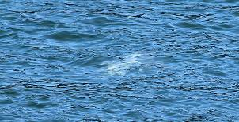

This porpoise has just gone under the surface; you can see what we call a ‘fluke’ print, the circular area where the water is rippled:
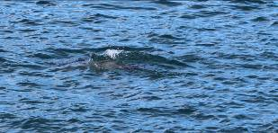

This photo was taken a little longer after 3 porpoises had gone underwater, but you can still see the 3 separate patterns of ripples. This is a great way to help keep track of where they are!
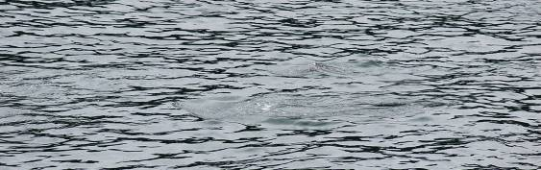

Behavior: Only record behavior if you are comfortable and confident in your observations. If you are unsure don’t record any behavior. In the Behavior (Beh) column you will put the main category which is one of the following: Foraging (F), Travel (T) or Porpoising (P), Rest (R) or Basking/Logging (B/L) and Social (S).

When documenting specific social behaviors please write out what you saw, e.g. tail slap, spy hop, rubbing, etc. Please email Aileen at porpoise@pacificbio.org with any questions on behavior. A PowerPoint slide show will be available on the website with definitions, pictures and links to video for reference.

Recording boat traffic: Tally the boat traffic in the boats columns, noting whether they are from the East or from the West. Mark the boats down at the time they enter the grid area, e.g., a boat that enters the area at 9:39 but takes 15 minutes to make its way through the pass should be tallied only in the 9:31-9:40 time interval.

Notes column: In the notes column, record any adult/calf pairs, remarkable behavior (feeding, leaping, resting), notable seal presence, weather changes, kayak, canoe, or diver activity, current patterns, or any other observations you wish to note. Remember we are still learning about these

Completing the observations: When you are finished, be sure to note the time and pack up all your belongings. If needed, there is a trash bin near the portable restroom at the top of the Burrows Pass overlook. Thank you!

Entering Data: Upon returning home enter the data from the form to the identical electronic form on your computer (be sure to save a blank copy to print out!). Enter all data in the appropriate cells (it is ok if it runs over the cell) and save with the date and your name as the filename (eg 51414Elliser). Please email the form to sarah.knudsen@pacificbio.org and aileen@pacificbio.org.

