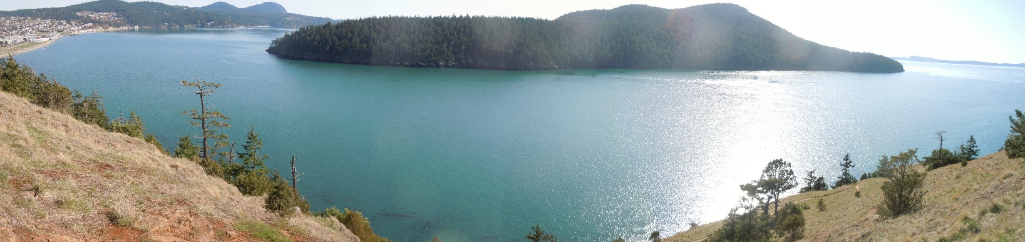

All of these images have distortion. Go by landmark features. The photo above is a panorama.

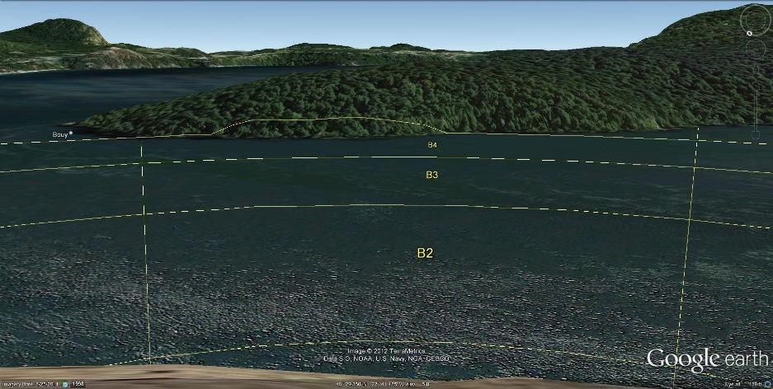

The photo to the right shows that the edge

of the 4th gridline just touches Burrows Island for cell B4 and that the edge of the second gridline appears to be more than halfway across the pass.

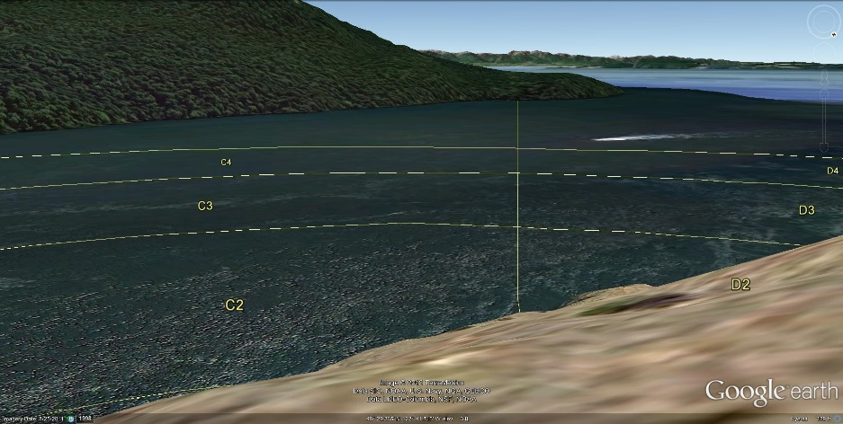

This photo shows that the edge of the 4th gridline at C4 and D4 does not touch Burrows Island. And it shows that much of cells D1 and D2 are hidden behind the hillside.

