**Environmental Impact of the European Beaver *Castor fiber* Summary (498 words)**

The European Beaver *Castor fiber* is a semi-aquatic rodent found in diverse freshwater ecosystems(1). They are herbivorous, their diet consisting of grasses, sedges and tree bark. They are monogamous, living in small family groups and producing litters of 1-3 young per year(1). On average, they live 7-8 years in the wild(1). They are territorial, using scent from their anal sacs to mark their territory, which limits their population density(1). In much of Europe, their primary predators, wolves and lynx, are rare or absent, so their populations are ultimately limited by food supply(1).

The beaver is native to Britain and was present in high numbers before hunting decimated populations for pelts, oil products from the anal sacs used in medicine and perfume, and meat(2). The British population was completely eradicated in the 16th century(1).

Reintroductions of the beaver have been carried out in recent years throughout Europe, starting in Sweden in the 1920s, progressing to the rest of Scandinavia, the Baltics and Eastern Europe by 1991(1). Many of these reintroductions were successful, owing to the beaver’s ecological plasticity and ability to adapt to a landscape changed in the years between its extinction and reintroduction, and the continued presence of its wetland habitat albeit in fragmented areas(1). The population of the European Beaver stood at 639,000 in 2003 up from 1,200 in 1900(3).

Discussion on reintroduction of the beaver in Britain began in 1995 as the UK government is obliged to consider the reintroduction of species under the European Council Directive on the Conservation of Natural Habitats and of Wild Flora and Fauna (the Habitats Directive). Furthermore, the beaver is on Scotland’s Species Action Framework and is a target of new management action(4). The culmination of these talks was the Scottish Beaver Trial, which reintroduced 16 beavers into the Knapdale reserve in Argyle in May 2009(4). There is also an unofficial population escaped from private collections on the Tay catchment.

The beaver is an ecosystem engineer, radically altering its habitat in terms of water level, species composition and tree cover by building dams and felling trees(1). They’re also fossorial, digging burrows in banks and drainage dykes(1)which has led them into conflict with man. In Scotland, the farming community fears that beavers may destabilise drainage earthworks and raise the water table with their dams, leading to the flooding of farmland. Fishermen are concerned about the effect of beaver dams on the migration of lucrative salmon populations, and siltation of gravel redds used for breeding(4). Finally forestry and horticulture industries and the general public have concerns about beavers’ propensity for felling trees which is economically damaging and perceived to be a danger to health and safety.

This essay will review the latest published literature to assess the environmental impact of beavers and likely consequences of their reintroduction into Scotland. It will cover the benefits to ecosystem function, species richness and diversity of beaver reintroduction, as well as reasons for conflict, and finally suggest solutions to minimise and mitigate for beaver damage.

**Environmental Impact of the European Beaver *Castor fiber* Review Essay** (1299 words)

Introduction

The European Beaver *Castor fiber* is a large semi-aquatic rodent found in diverse freshwater ecosystems throughout Eurasia(1). They are herbivorous, monogamous and live in small family groups (1). Throughout the last few hundred years their populations have suffered from hunting due to high demand for their pelts, oil secretions and meat, with the British population hunted to extinction in the 16th century(2). In order to reverse this decline, the beaver was reintroduced into Sweden in the 1920s and many other European countries over the past 90 years(1). Discussion on reintroduction began in Scotland in 1995 and culminated in the release of 16 Norwegian beavers to the Knapdale reserve in Argyle in May 2009(4). There is also an unofficial population of beavers which escaped from private collections on the Tay catchment.

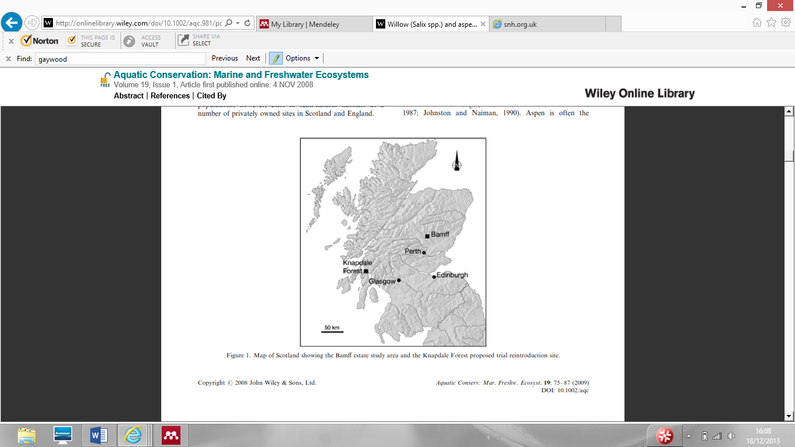



The beaver is an ecosystem engineer so has a marked impact on its environment in terms of geomorphology, hydrology and biology of the landscape(5). By felling trees and building dams, beavers can increase the heterogeneity, habitat and species diversity of freshwater ecosystems, and by foraging they can alter the course of ecological succession, species composition and structure of plant communities(5). This disturbance has brought them into conflict with humans. In particular farmers fears that beavers may destabilise drainage earthworks leading to the flooding of farmland. Fishermen are concerned about the effect of beaver dams on the migration of lucrative salmon populations, and siltation of gravel redds used for breeding(4). Finally forestry and horticulture industries and the general public have concerns about beavers’ propensity for felling trees which is economically damaging and perceived to be a danger to health and safety.

The paragraphs below will summarise the findings in the literature on the environmental impact of beavers, to assess the magnitude of the effect of reintroduction on vegetation, other biota and stream dynamics.

Impact on Geohydrology

Beavers can alter the structure of river corridors by altering their channel morphology and vegetation characteristics(6). They can also alter their function by altering their productivity, connectivity, resistance and resilience to perturbations, as beaver ponds can buffer the system by their large mass and slow turnover of water(6). Beaver dams can reduce the kinetic energy of water in upland streams(7)with older beaver dams reducing velocity and discharge more efficiently(8). This slowing down of the water column can increase sedimentation rates which can in turn reduce the heterogeneity of benthic substrate as gravels and sands are covered by homogenous silt(9). This also results in changes in edaphic conditions, with deep silt deposits becoming anoxic over time(7). By storing water behind dams, beavers can maintain flow in intermittent streams in dryer periods while other non-dammed streams may dry out(10). They can also raise the water table in the surrounding landscape and lead to submersion and conversion of field to floodplains(7).

Impact on vegetation

Beavers are central place foragers so limit their herbivory to the riparian zone within 100m of the closest pond, creating a grazed strip along the river(7). Vegetation clearance can be considerable, with an individual felling on average a ton of vegetation each year(7). Beavers’ have been found to selectively fell willow and aspen for food, but this is combined with an increase in regrowth rates in these species and creates a varied structure in woodland(11). This is because both willow and aspen have high vegetative suckering capacity, and in some cases the felling isn’t complete with the stump and trunk still connected by the cambium layer(11). Beavers tend to fell in autumn and winter when trees are dormant(12), and correspondingly willow felled at this time showed highest regrowth rates.

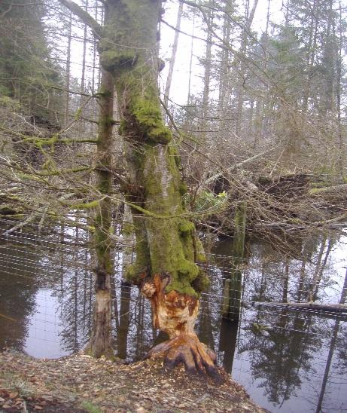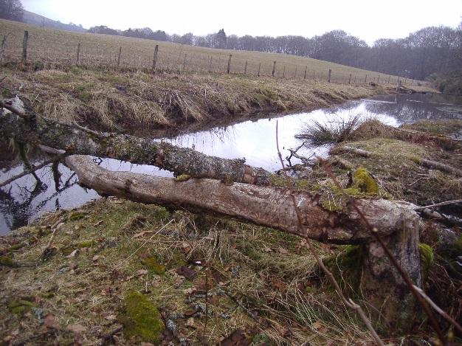

A

B



Regeneration has been found to occur even when combined with moderate grazing by roe deer(11). The resulting mosaic of different age classes of vegetation would support a wider range of willow and aspen dependent flora and fauna(13) and so could be beneficial for biodiversity.

Impact on biota

Beavers’ habit of felling trees and transporting cut logs to the river as feeding caches for the winter can benefit biodiversity. Beavers can increase the availability of organic material for other organisms as they rarely consume all the plant material from felled trees(5). Beaver activity can enhance biological production resulting in a high standing crop of aquatic invertebrates and increased food-web complexity (14). This is due to an increase in the retention of fine particulate organic matter trapped by the dams, leading to reduced macroinvertebrate richness and diversity, but increased biomass and production (15). Feeding guilds that particularly benefit include the collector-gatherers such as Chironomidae and the predators(16). The Ephemeroptera, Plecoptera and Trichoptera were found to be lower in abundance and diversity in beaver disturbed rivers in Lithunania, as they are highly sensitive to environmental change(9). But an increase in overall abundance can benefit organisms higher up the food chain such as fish, amphibians and birds.

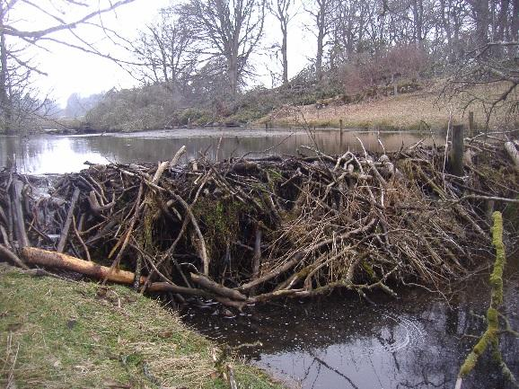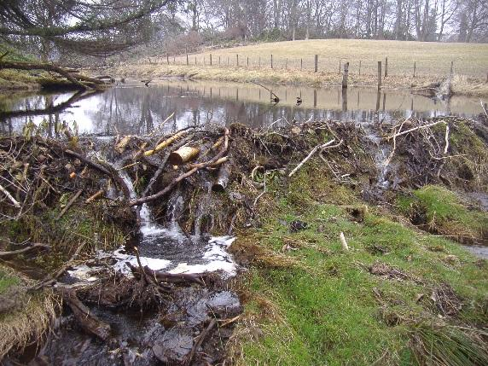Beavers’ impact on fish is more complicated with numerous positive and negative impacts possible. The negative impact of dams on fish migration is temporal; some beaver dams posed serious obstacles to upstream migrating Atlantic salmon, especially at low flow(17), however the majority of beaver dams in most years had no effect. Furthermore dams are not permanent structures but frequently wash out at high discharge(18). In comparison to North American beaver dams, the European variety are lower in frequency, smaller and shorter in lifetime so are thought to have a lesser effect on salmonid migration(19).

D

C

The effects of siltation above the dam due to slow flowing water can be more problematic for salmonids, by reducing the availability of gravel spawning redds. In one study, no redds were found in a stretch 100-300m above the dams(17). But increased siltation on tributaries may hold back sediment from important spawning sites downstream(20). Beaver presence can increase water temperature by removing shading vegetation and so opening the water up to insolation. This can be a problem if the water was already close to a species’ thermal maximum, and is more serious in summer(21). Finally beavers can reduce water quality by decreasing the dissolved oxygen content of the water, due to the presence of decomposing vegetation in their food caches(21).

Beaver dams on the Bamff estate, Perthshire. Photo C shows the magnitude of some beaver dams and difficulty faced by a migrating fish, while photo D shows the transience of such structures, with overflowing water providing a migration route. Photo credit Izzie Tween.

Positively, numerous fish species actively select beaver created habitats including brown trout(22). It’s further been observed that fish quickly colonise beaver-flooded peatland and that this habitat supports multi-fish assemblages(14). The stable temperatures and reduced ice cover of ponds can provide important overwintering sites for fish(23). With their relatively slow waters and high invertebrate productivity, beaver ponds provide important rearing habitat for anadromous fish species(24). The presence of food caches and dams can also provide cover from predators(20). Beaver ponds can act as refuges for many species during periods of low flow such as summer(25) and also slack water during periods of peak discharge(18). As a result of this combination of factors, some papers have cited an improvement in angling, especially of trout species (26,27).

Conclusion

It is clear to see that beavers have a dramatic impact on their environment, altering species composition and abundance in both the aquatic and riparian zone. While many of these changes can benefit biodiversity, the effects vary on the species and location and some may be adversely affected in some cases. This can lead to conflict with man, which may undermine the success of the beaver’s reintroduction. Where conflict exists, solutions are available that can protect both the resource and the beaver’s requirements. Individual trees and woodlands can be protected by wire wrapping and fencing, although this can be costly(1). Alternatively, landowners can be compensated for beaver damage. This may be a more cost effective solution as beaver damage is often dispersed thinly over a large area(1). With these mitigation measures in place, it is hoped that the presence of the beaver need not be intolerable and can persist and proliferate successfully, as it has in many other European countries.

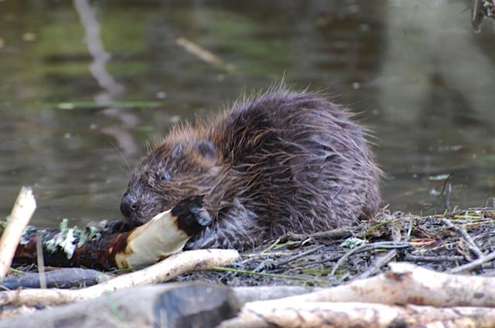



References

1. Bart A. Nolet & Frank Rosell. COMEBACK OF THE BEAVER Castor fiber: AN OVERVIEW OF OLD AND NEW CONSERVATION PROBLEMS. Biol. Conserv. 1998;83(2):165–73.

2. Gorman ML. Restoring ecological balance to the British mammal fauna. Mamm. Rev. [Internet]. 2007;37(4):316–25. Available from: http://www.blackwell-synergy.com/doi/abs/10.1111/j.1365-2907.2007.00113.x

3. Duncan J. Halley & Frank Rosel. Population and distribution of European beavers (Castorfiber) . Lutra [Internet]. 2003;46(2):91–101. Available from: https://teora.hit.no/bitstream/handle/2282/534/Population_and_distribution.pdf?sequence=3

4. Kemp, P.S., Worthington, T.A. & Langford TEL. A critical review of the effects of beavers upon fish and fish stocks. Scottish Nat. Herit. Comm. Rep. 2010;No. 349(iBids No. 8770).

5. FRANK ROSELL OBPCHP. Ecological impact of beavers Castor fiber and Castor canadensis and their ability to modify ecosystems. Mammal Rev. [Internet]. 2005;35(3-4):248–76. Available from: http://onlinelibrary.wiley.com/doi/10.1111/j.1365-2907.2005.00067.x/full

6. Naiman R. Melilo J. HJ. Ecosystem alteration of boreal forest stream by beaver (Castor canadensis). Ecology. 1986;67:1254–69.

7. Johnston CA, Naiman RJ. Boundary dynamics at the aquatic-terrestrial interface: The influence of beaver and geomorphology. Landsc. Ecol. 1987. p. 47–57.

8. Meentemeyer RK, Butler DR. Hydrogeomorphic effects of beaver dams in Glacier National Park, Montana. Phys. Geogr. 1999;20(5):436–46.

9. Kesminas V, Pliūraitė V. Ecological impact of Eurasian beaver (Castor fiber) activity on macroinvertebrate communities in Lithuanian trout streams. Cent. Eur. J. Biol. 2012. p. 101–14.

10. Rutherford WH. ) Wildlife and environmental relationships of beavers in Colorado forests. J. For. 1955;53:803–6.

11. Jones K. Willow (Salix spp.) and aspen (Populus tremula) regrowth after felling by the Eurasian beaver (Castor ﬁber): implications for a riparian woodland conservation in Scotland. Aquat. Conserv. Mar. Freshw. Ecosyst. [Internet]. 2009 [cited 2013 Dec 4];19(1):75 – 87. Available from: http://www.worldcat.org/title/willow-isalixi-spp-and-aspen-ipopulus-tremulai-regrowth-after-felling-by-the-eurasian-beaver-icastor-fiberi-implications-for-riparian-woodland-conservation-in-scotland/oclc/5155985130&referer=brief_results

12. Hodgdon HE, Lancia RA. Behavior of the North American beaver, Castor canadensis. THIRD Int. Theriol. Congr. Symp. LAGOMORPHS, BEAVER, BEAR, WOLF MUSTELIDS. Acta Zoologica Fennica; 1983. p. 99–103.

13. Torley. D. Woodland management measures for Aspen woodlands. Biodivers. Manag. Aspen Woodlands Proc. a one-day Conf. held Kingussie, Scotland, 25th May 2001,. 2002;Pamphlett(The Cairngorms Local Biodiversity Action Plan: Grantown-on-Spey, UK):59–62.

14. Ray HL, Ray AM, Rebertus AJ. Rapid establishment of fish in isolated peatland beaver ponds. Wetlands. 2004. p. 399–405.

15. Anderson C. RA. Ecosystem engineering by invasive exotic beavers reduces in-stream diversity and enhances ecosystem function in Cape Horn, Chile. Oecologia. 2007;154:141–53.

16. McDowell D. NR. Structure and function of a benthic invertebrate stream community as influenced by beaver (Castor canadensis). Oecologia. 1986;68:481–9.

17. Taylor BR, MacInnis C, Floyd TA. Influence of rainfall and beaver dams on upstream movement of spawning Atlantic salmon in a restored brook in Nova scotia, Canada. River Res. Appl. [Internet]. John Wiley & Sons, Ltd.; 2010;26(2):183–93. Available from: http://dx.doi.org/10.1002/rra.1252

18. Taylor J. Burning the candle at both ends - Historicising overfishing in Oregan’s nineteenth century salmon fisheries. Environ. Hist. Durh. N. C. 1999;4:54–79.

19. Parker H, Ronning OC. Low potential for restraint of anadromous salmonid reproduction by beaver Castor fiber in the Numedalslagen River catchment, Norway. River Res. Appl. [Internet]. 2007;23:752–62. Available from: <Go to ISI>://WOS:000250059100005

20. Beedle D. Physical dimensions and hydrologic effects of beaver ponds on Kuiu Island in southeast Alaska. Unpubl. masters thesis. 1991;Oregon Sta.

21. Guignion D. A Conservation Strategy for Atlantic Salmon in Prince Edward Island. Atl. Salmon Conserv. Found. 2009;

22. M.Young. Telemetry – determined diurnal positions of brown trout (Salmo trutta ) in two south-central Wyoming streams. Am. Midl. Nat. 1995;133:264–73.

23. Lindstrom JW, Hubert WA. Ice Processes Affect Habitat Use and Movements of Adult Cutthroat Trout and Brook Trout in a Wyoming Foothills Stream. North Am. J. Fish. Manag. 2011;24(4):1341–52.

24. Johnson J. Weiss E. Catalog of Waters Important for Spawning, Rearing or Migration of Anadromous Fishes, Southwestern Region, Anchorage, Alaska. Alaska Dep. Fish Game, Div. Sport Fish, Res. Tech. Serv. 2006;

25. Bruner K. Effects of beaver on streams, streamside habitat, and coho salmon fry populations in two coastal Oregon streams. Unpubl. masters thesis. 1990;Oregan Sta.

26. Neff DJ. Ecological effects of beaver habitat abandonment in the Colorado Rockies. J. Wildl. Manage. 1957;21:81.

27. Grasse J. Beaver ecology and management in the Rockies. J. For. 1951;49:3–6.

SNH library on beaver reintroductions

<http://www.snh.gov.uk/protecting-scotlands-nature/safeguarding-biodiversity/reintroducing-native-species/scottish-beaver-trial/other-work-on-beavers/>